**Assignment-8**

**Problem statement:** Deploy a project from local machine to Github and vice versa

**Procedure:**

1. Login to your GitHub account and click new repository and create new repository & make it public

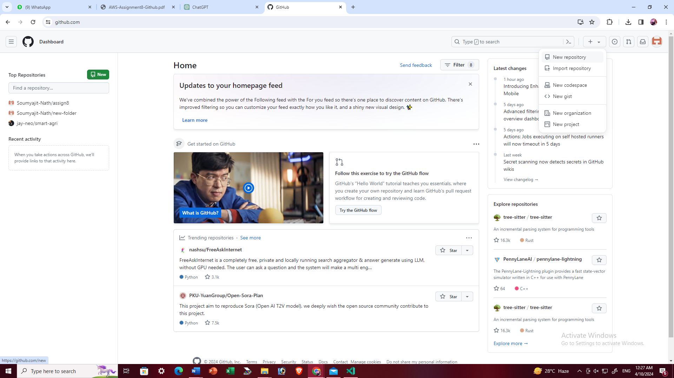

1. Write the repository name then click on create repository and set as public

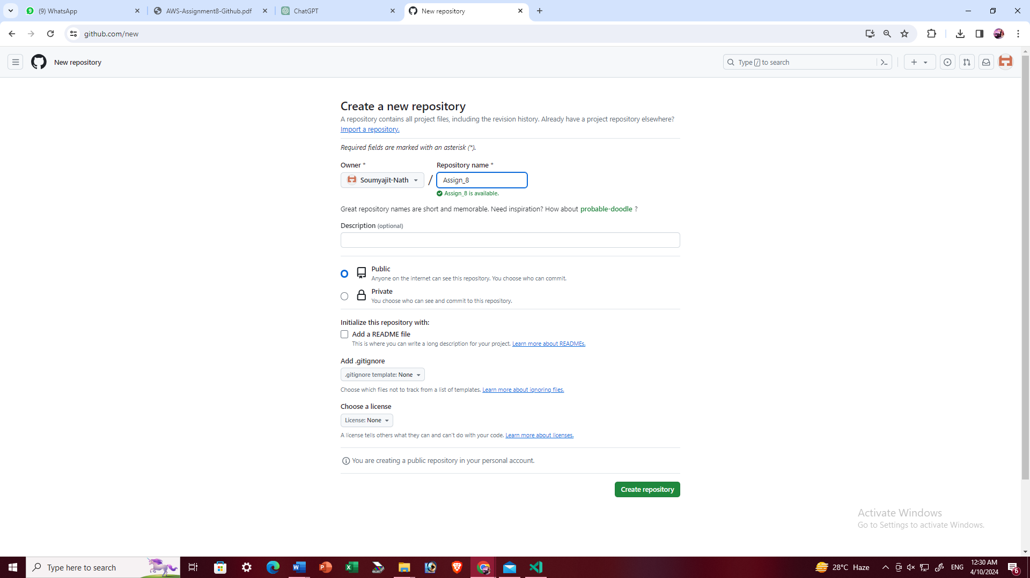

1. The repository is created

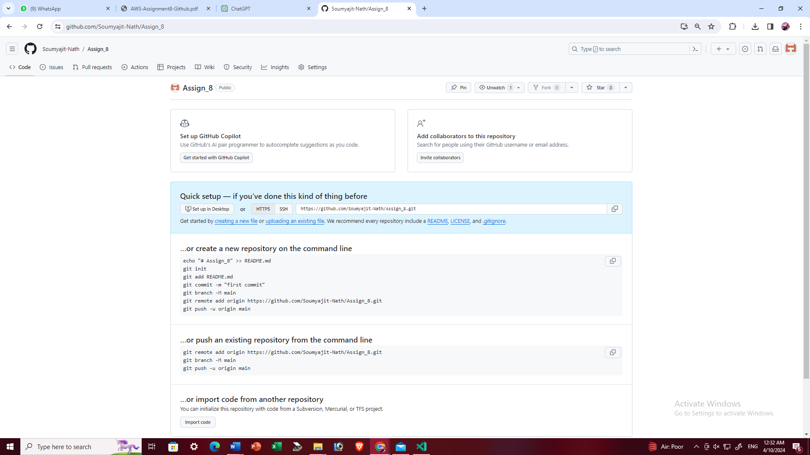

1. After creating new repository, go to Settings → Developer Options →Personal Access Token→Token (Classic) → Generate new token (classic)

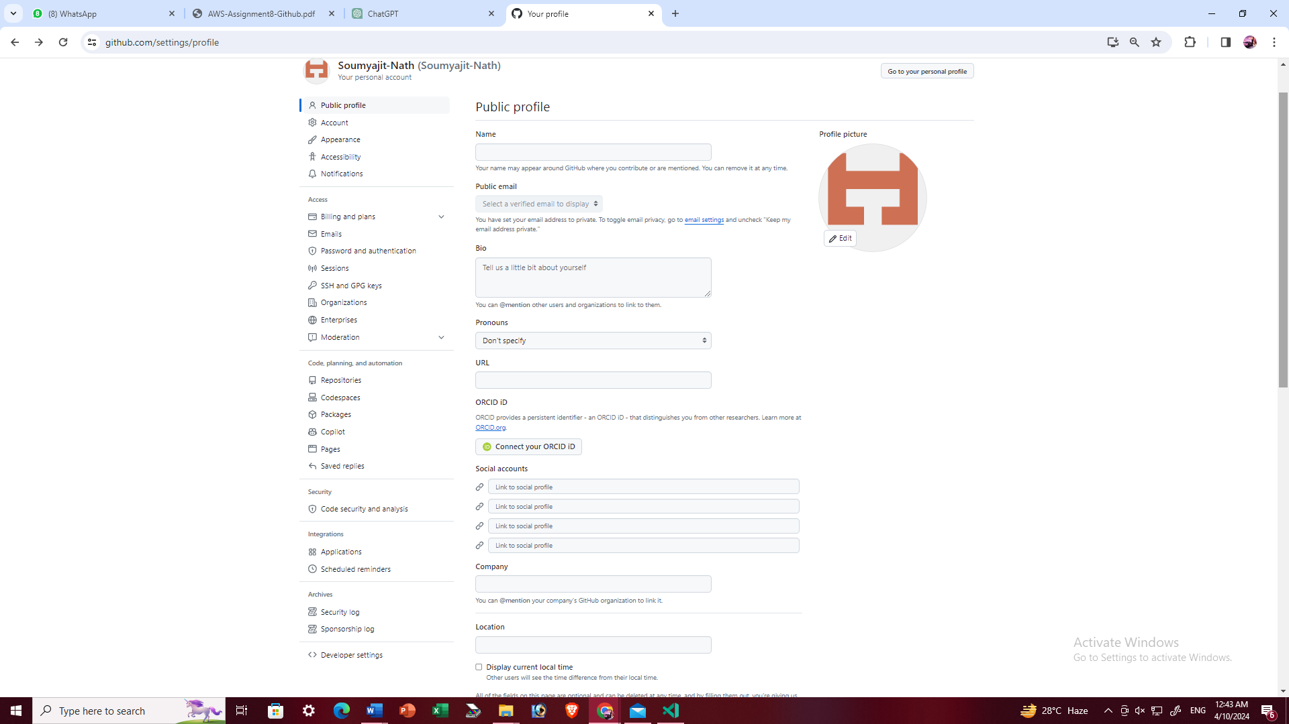

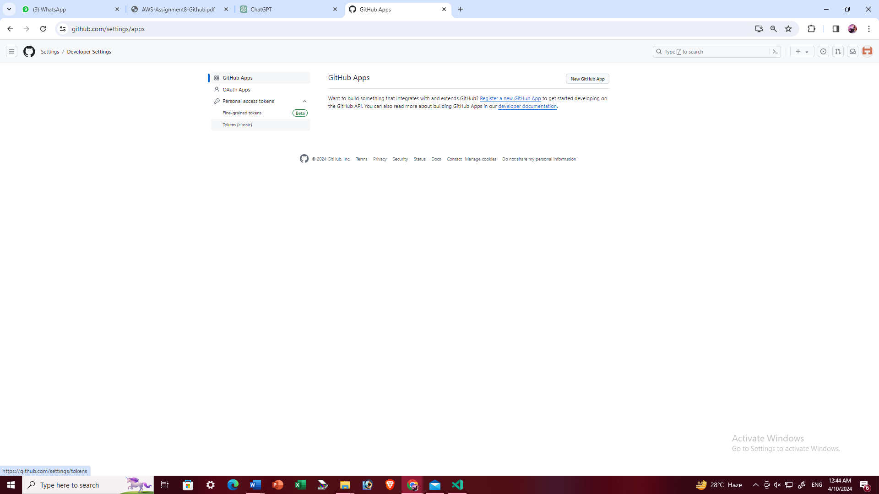

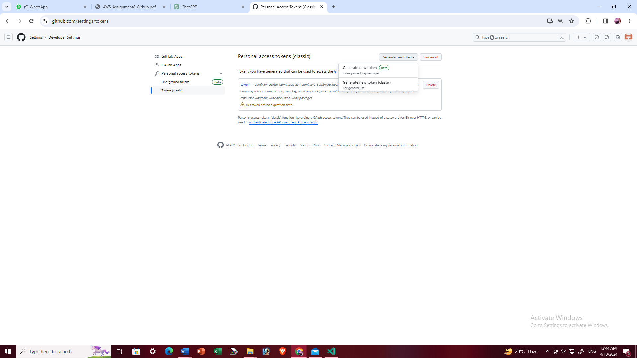

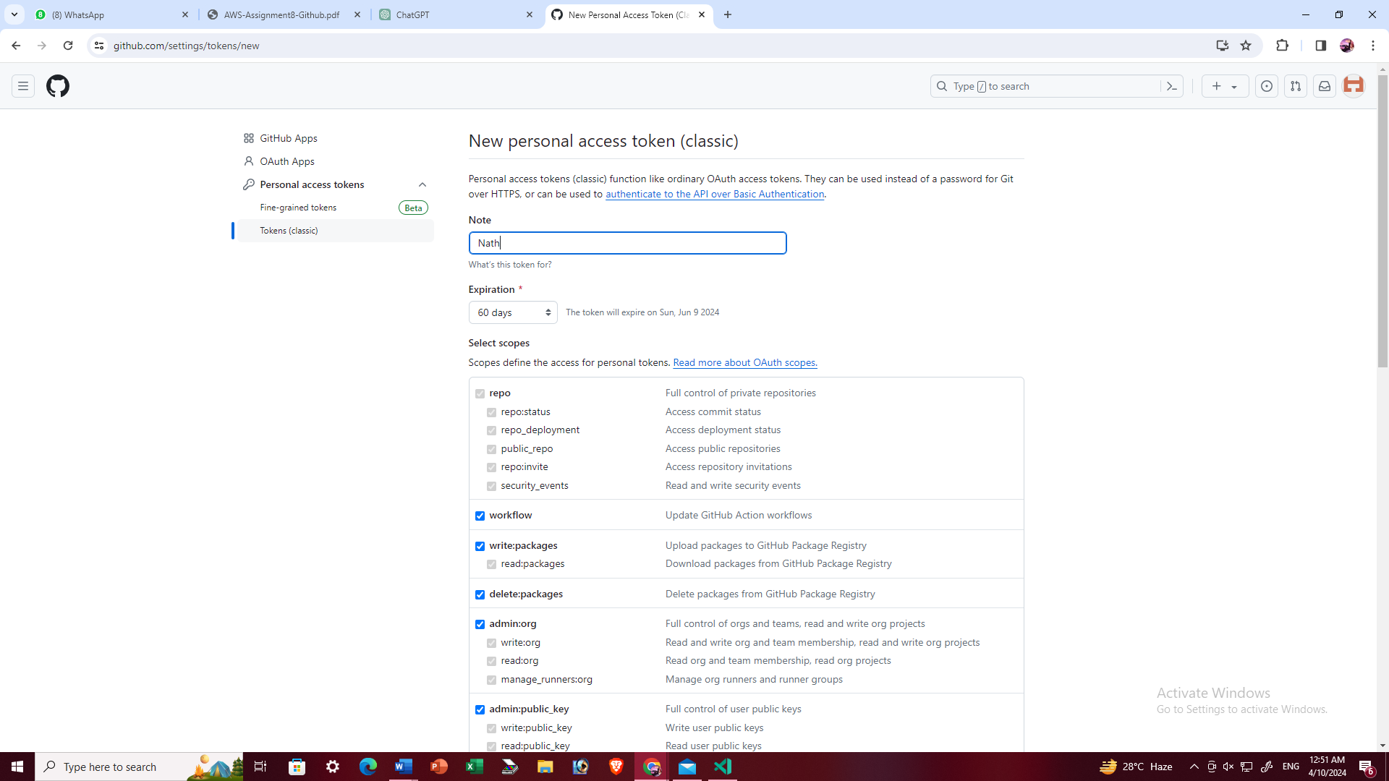

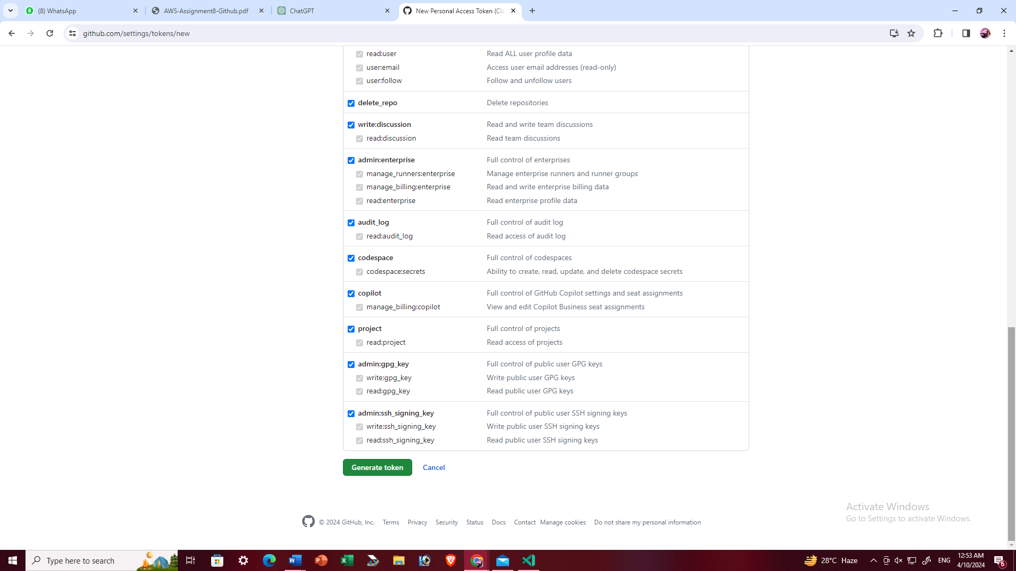

Token is generated

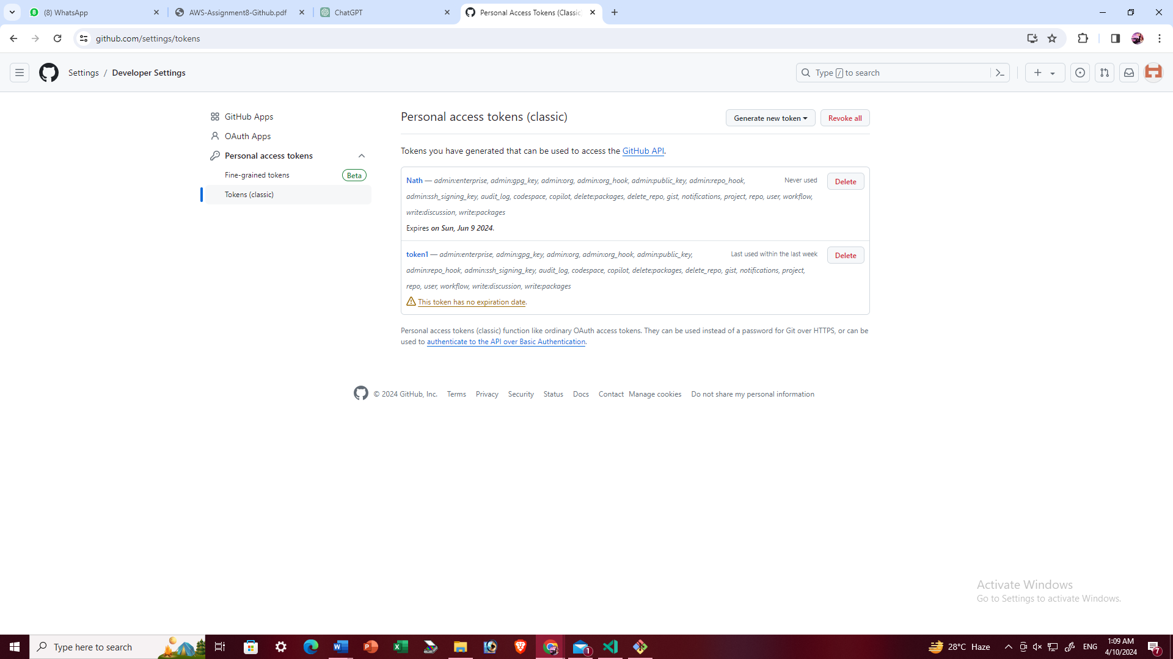

1. In the local machine install git. Next the following commands are the required for the initialize new git repositroy in your local machine and upload local repository in to github platform using git client via https protocol with pre-generated token.

- git init

- git add .

- git commit -m “enter any comment”

- git remote add <

- git push -u <remote><branch>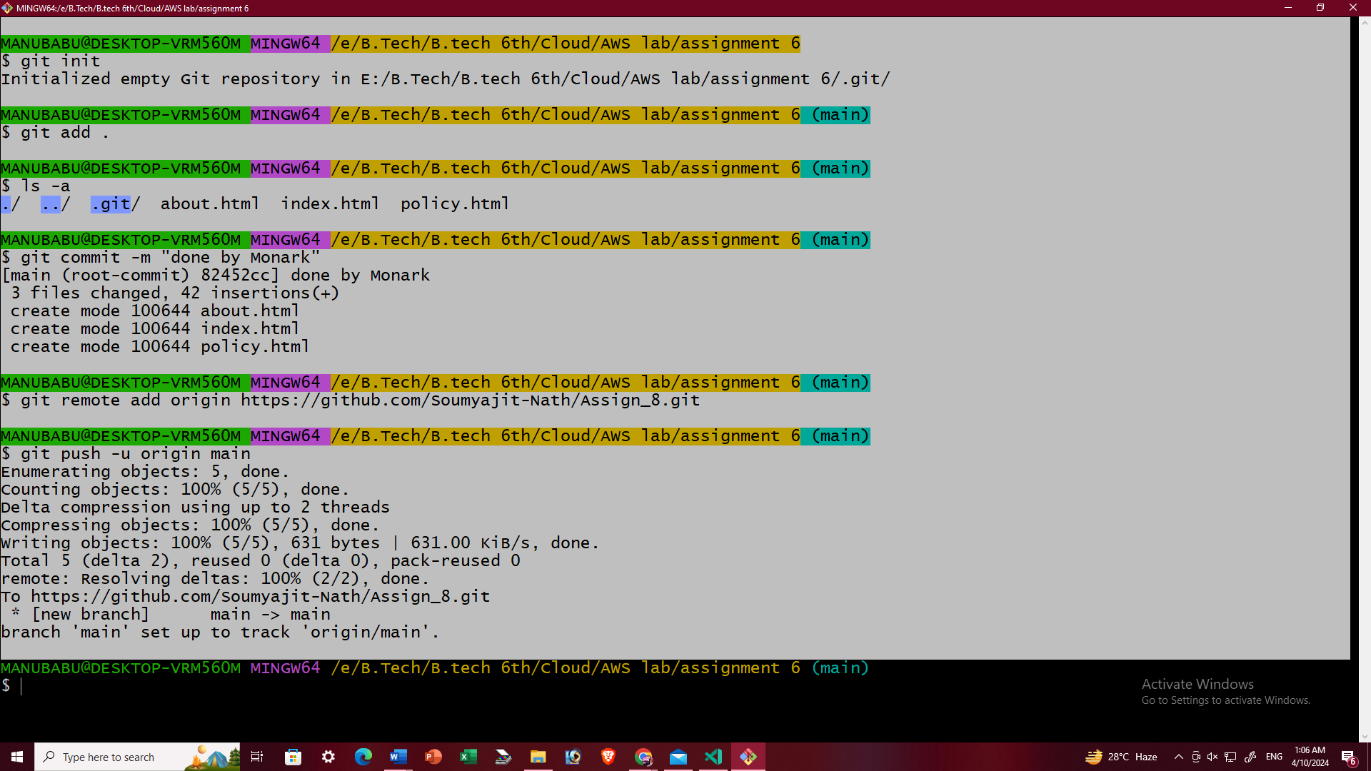

The files are uploaded successfully in the repo

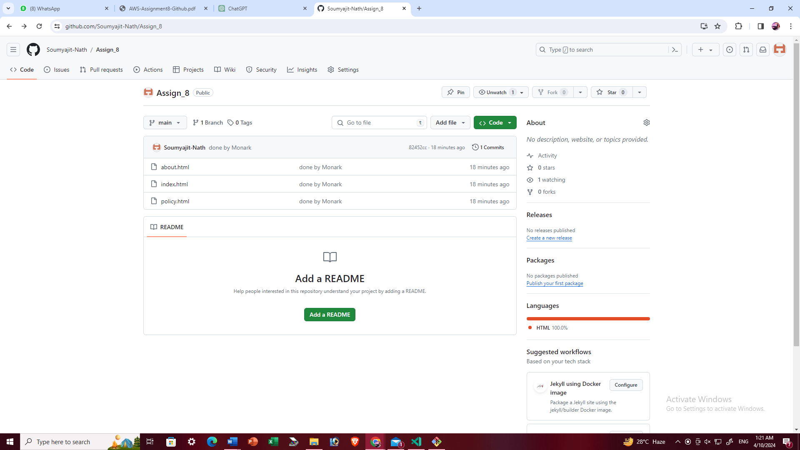

From our local machine: To download public repository from GitHub:

